**Lab Guide 10**

Manual And Automatic Scaling

Q.1 Create one deployment using nginx image and scale it manually to 5 pods

Q.2 Create one dep and scaling up or down should happen automatically with respect to CPU usage.

Ans: 1

kubectl create deployment webserver --image nginx

kubectl get all

kubectl get pods

kubectl scale deployment webserver --replicas=5

kubectl get pods

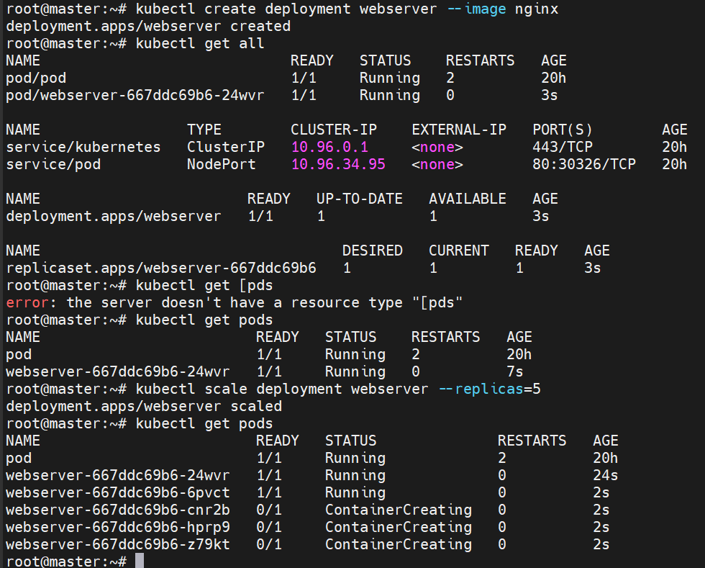

Ans.2

Create dephpa.yml file

vim dephpa.yaml

apiVersion: apps/v1

kind: Deployment

metadata:

name: php-apache

spec:

selector:

matchLabels:

run: php-apache

replicas: 1

template:

metadata:

labels:

run: php-apache

spec:

containers:

- name: php-apache

image: k8s.gcr.io/hpa-example

ports:

- containerPort: 80

resources:

limits:

cpu: 500m

requests:

cpu: 200m

---

apiVersion: v1

kind: Service

metadata:

name: php-apache

labels:

run: php-apache

spec:

ports:

- port: 80

selector:

run: php-apache

kubectl create -f dephpa.yaml

kubectl get all

kubectl top node

kubectl autoscale deployment php-apache --cpu-percent=50 --min=1 --max=10

kubectl run -i --tty load-generator --rm --image=busybox:1.28 --restart=Never -- /bin/sh -c "while sleep 0.01; do wget -q -O- http://php-apache; done"

kubectl get hpa php-apache –watch

